**Extend Windows Disk**

1. Right-click My Computer and choose Manage -> Storage -> Disk Management.

2. Select the adjacent disk of the disk you want to extend, right click and choose Shrink Volume to create some free disk space.

3. Select the disk you want to extend, right click and choose Extend Volume to expand the partition.

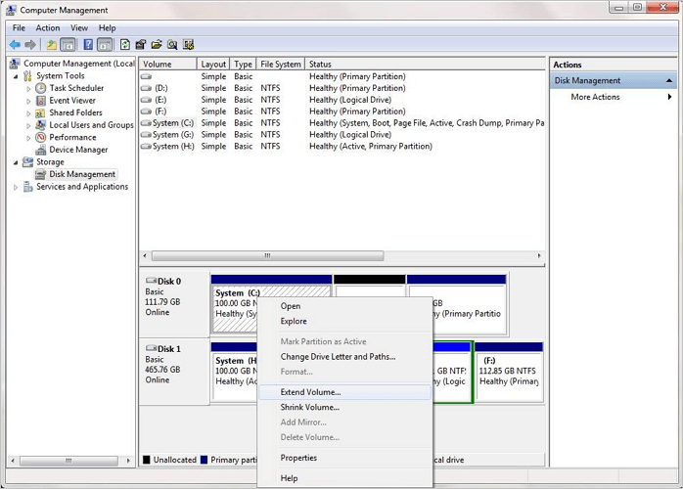

4. Set and add more size to your target partition and click Next to continue.

Follow the onscreen guidelines to complete the process.

